Methodology
Statistics

We used the generalized linear model (GLM) with binomial distribution of errors for the quantification of the effects of environmental variables (depth of soil layer and substrate type) on germination of L. uniflora seeds. The significance Our working hypothesis was that number of germinated seeds will degrease with increasing sediment depth and also for unsuitable substrates. The function dose.p from the R package MASS (Venables and Ripley 2002) was used for the estimation of soil depth, which is impenetrable for 95 % of seeds. The significance level was set at 5%. Data management and all analysis were carried out using the R statistical program (R Core Team, 2015).

Results

Experiment 1+2
Only 83 seeds of L. uniflora were able to germinate from 600 in total, 17 at the climatic chamber (n = 300) and 66 at the glasshouse experiment (n = 300). Mean germination capability of control groups in laboratory and glasshouse experiment was 13.3 % (10 seeds in total, SD = 12.85 %) and 53.3 % (40 seeds in total, SD = 6.11 %), respectively. Mean percentage of successfully germinated seeds in our soil depth experiment (treatments 0, 1, 3 and 5 cm) were 36.6 % (26 seeds in total, SD = 9.23 %), 0 and 0 in the glasshouse and 9.3 % (7 seeds in total, SD = 8.32 %), 0 and 0 in the climatic chamber experiment, respectively. We confirmed significant difference in germination between our experimental set-ups (z value = -6.032, p < 0.001) and also in case of increasing soil depth (z value = -6.993, p < 0.001).
We did not find any interaction between experimental design and treatments (soil depth) (z value = 0.857,
p = 0.391) therefore the effect of soil depth should be constant.
These findings support our hypothesis that number of successfully germinated seeds of L. uniflora is declining with increasing soil depth (see Fig. X?).
Estimation of mean soil depth, which was impenetrable for 95 % seeds, is highly influenced by seed germination probability, therefore it is different for each experiment. In the glasshouse experiment we estimated that 2.54 cm (SE = 0.305) was enough to prevent germination of 95 % seeds. In the climatic chamber it was 1.06 cm (SE = 0.229).

Experiment 3 - substrate variability/suitability

Pro ověření vhodnosti klíčících substrátů pro semena LU bylo použito 8 základních typů substrátů či jejich kombinací a kontroly. Kontrola prokázala 49% klíčivost použitých semen. Rozdíl v klíčivosti semen byl statisticky průkazný () a zároveň u všech typů substrátu se lišil od kontroly (viz. Tabulka 1). Nejúspěšněji semena klíčila v rybničním bahně (24% klíčivost) či v kombinaci bahna s pískem (14%). Naopak nejhůře dopadlo klíčení v ornici, v níž nevyklíčilo ani jedno semeno ze sta použitých (0% klíčivost) a klíčení v kombinaci rašeliny a rybničního bahna (3% klíčivost).

Tabulka 1: Klíčivost semen na různých druzích substrátu.

Figures

1Klimaboxo prokličování
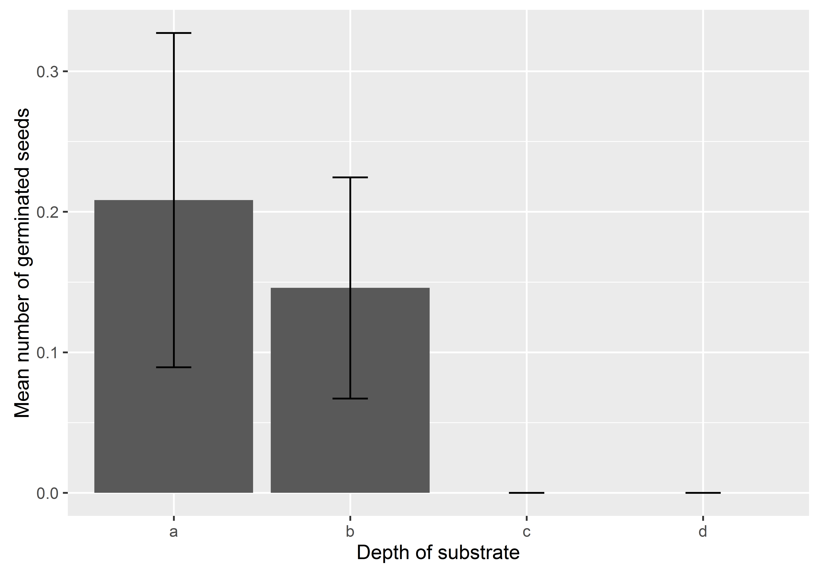
2.Skleníkovo prokličování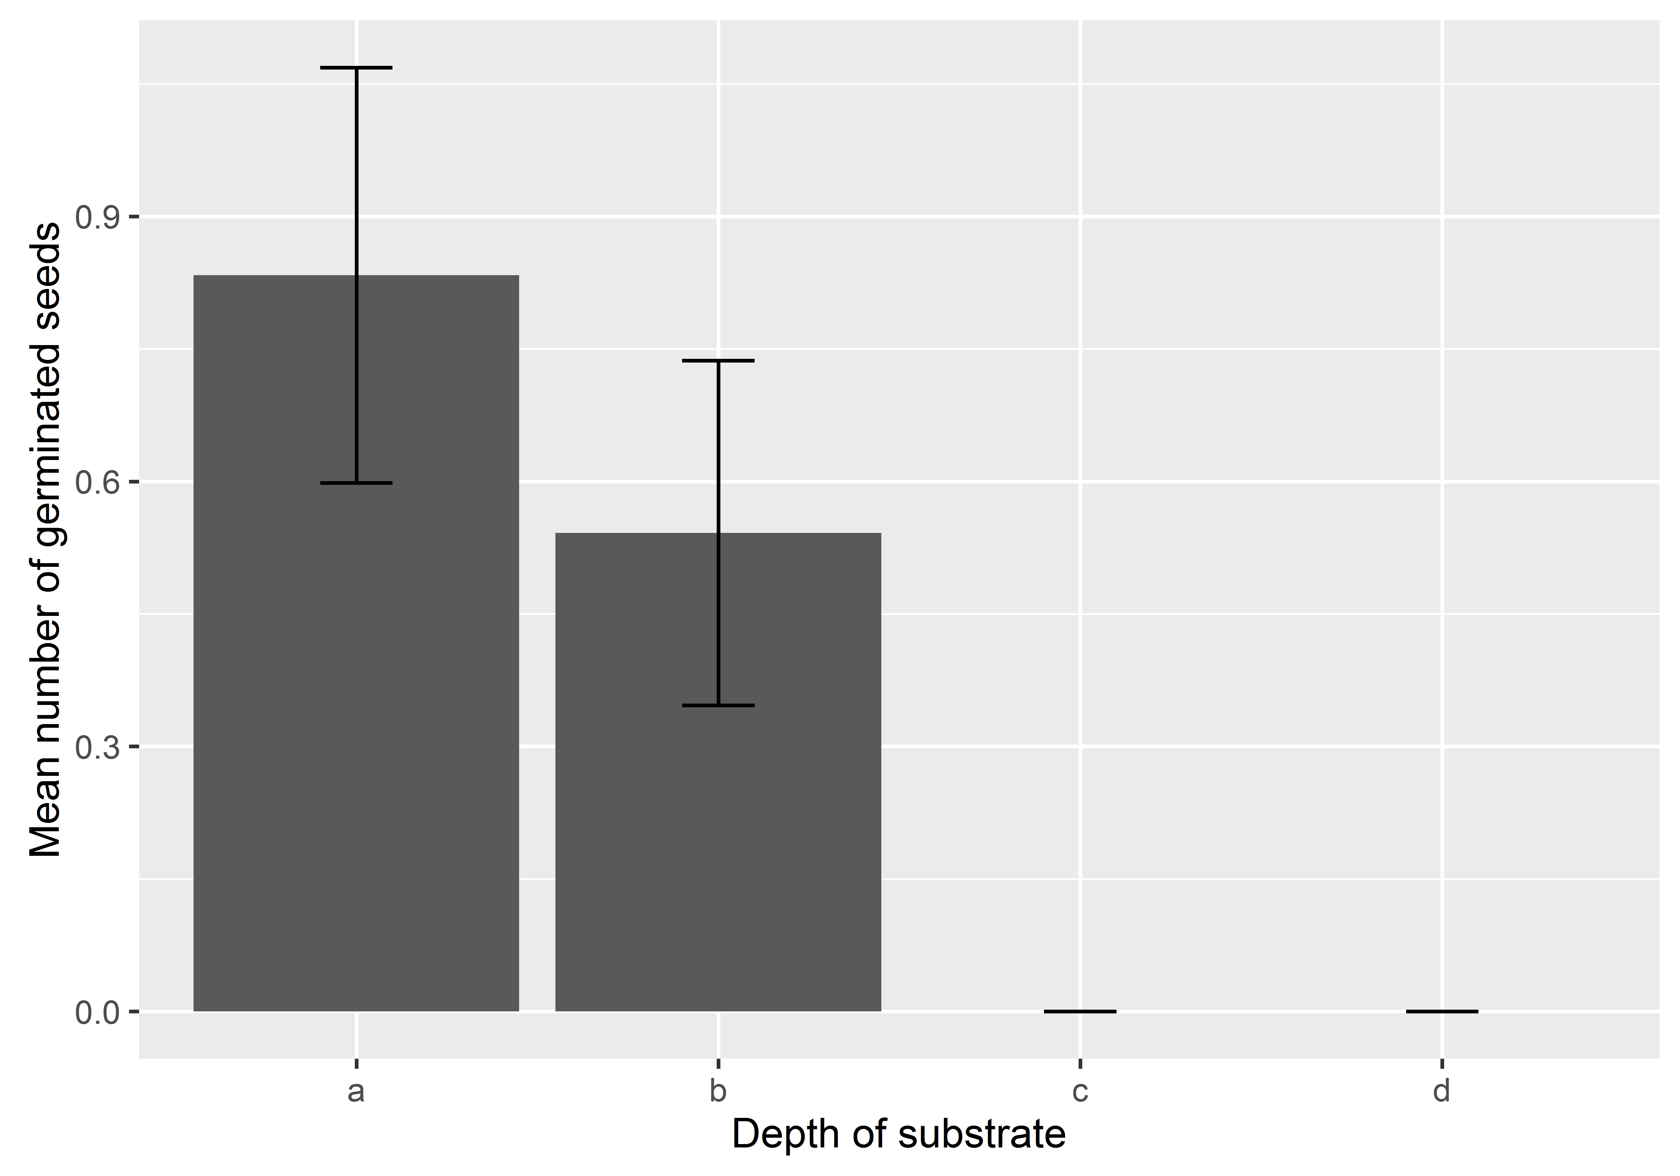
3. Klíčení na substrátech
